WLNM performance metrics across varying train/test splits for 30 randomly selected food webs. Each boxplot shows the distribution of Recall, AUC, Precision, and F1-score across food webs for a given training ratio. The results demonstrate that WLNM maintains high predictive performance across all tested splits, with median AUC consistently above 0.9. Notably, performance remains stable even when reducing the training data from 80% to 60%, indicating strong generalization capabilities of the model.

WLNM prediction performance grouped by ecosystem type at a fixed training ratio of 80%. Each boxplot represents the distribution of AUC, Precision, Recall, and F1-score across food webs within the same ecosystem category. The model achieves consistently high performance in terrestrial aboveground and lake ecosystems. In contrast, food webs from marine systems exhibit higher variability and lower median scores, likely reflecting greater structural heterogeneity or sampling biases in marine datasets. This suggests ecosystem type influences prediction difficulty and model generalization.

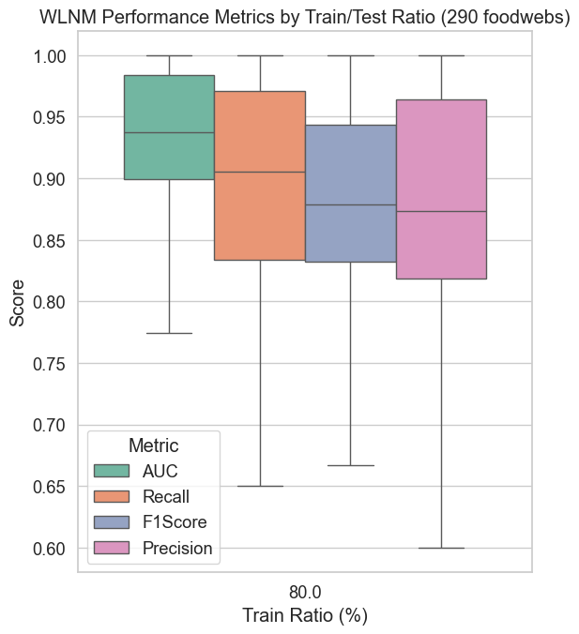

Overall WLNM performance across 290 empirical food webs using an 80/20 train/test split. Boxplots summarize AUC, Recall, F1-score, and Precision. The model shows robust predictive performance, with median AUC and Recall above 0.90 across all networks. Despite variability in network structure and ecosystem type, the WLNM maintains consistently high performance, confirming its scalability and generalizability for large-scale ecological link prediction.

Comparison between the original adjacency matrix (left) and the model's predicted interactions (right) for the Beaver Lake food web. Species are ordered by increasing body mass (prey: bottom to top, predators: left to right). On the right panel, green diamonds indicate training links, black circles represent true positives (TP), gray crosses indicate false positives (FP), and red squares denote false negatives (FN). The model successfully recovers most true links while maintaining few false predictions, particularly for larger-bodied species. This visualization illustrates both the structure preserved in training and the ecological plausibility of predicted interactions.

Original (left) and predicted (right) predation matrices for the F2P1 food web, with species ordered by increasing body mass. The right panel highlights training links (green diamonds), true positives (black circles), and false positives (gray crosses). While the model successfully captures a large portion of known interactions—particularly in densely connected predator groups—it also generates a notable number of false positives, especially among species with broader diets. This case highlights the trade-off between recall and precision in structurally complex or densely connected networks.

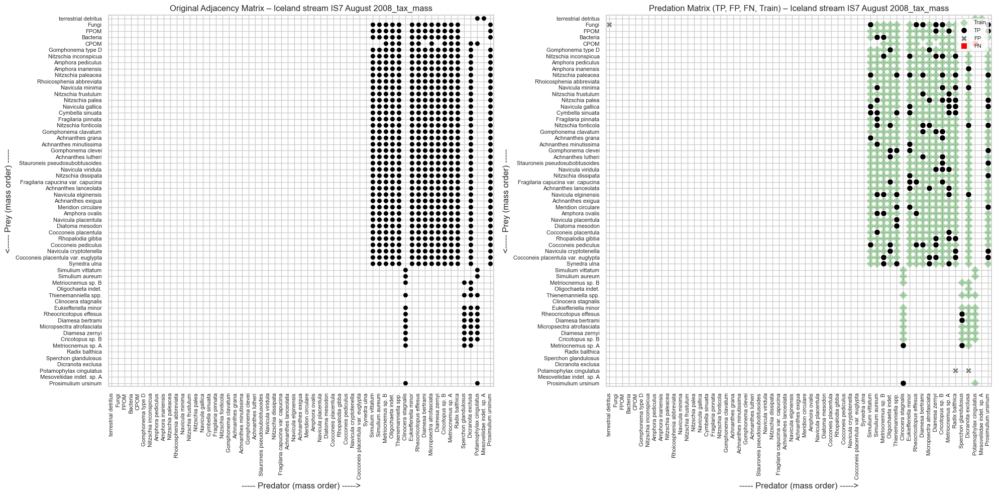

Original (left) and predicted (right) trophic matrices for the Iceland stream IS7 (August 2008) food web. Nodes are ordered by body mass, with prey from bottom to top and predators from left to right. The right panel marks training links (green diamonds), true positives (black circles), false positives (gray crosses), and false negatives (red squares). WLNM captures the dense predation structure concentrated in higher trophic levels, with minimal false negatives. The few false positives observed primarily involve less-connected species, suggesting the model favors well-supported interaction zones within the network.

Original (left) and predicted (right) trophic interaction matrices for the Big Hope Lake food web, with species ordered by increasing body mass. Training links are marked in green, while black circles, gray crosses, and red squares denote true positives (TP), false positives (FP), and false negatives (FN), respectively. The model correctly recovers most of the structured predation zones, particularly among top predators, with relatively few false positives. Some overpredictions occur at mid-trophic levels, suggesting WLNM tends to generalize link structures where ecological roles are less distinct.